STEP-BY-STEP SOLUTION

Task 1 — Create the Project Structure
Goal
Create the required folders and files for the Ansible project.
Step 1 : Activate your existing Python virtual environment.
source ~/ansible-onboarding/.venv/bin/activate
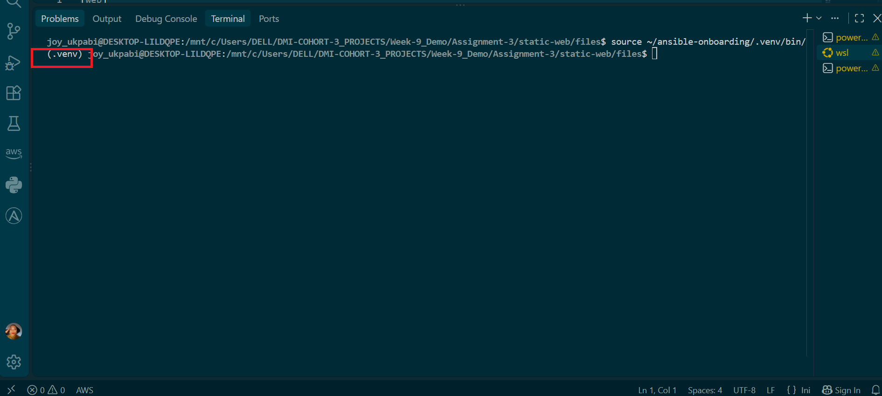

Step 2 — Create the Project Directory Structure
Goal
Create the dedicated static-web project folder — separate from the earlier ansible-adhoc-lab project — along with a files/ subfolder to hold the website content, and the empty files the rest of the assignment will fill in.
Commands
bash
cd ~/ansible-onboarding
mkdir -p static-web/files
cd static-web
touch inventory.ini site.yml README.md files/index.html
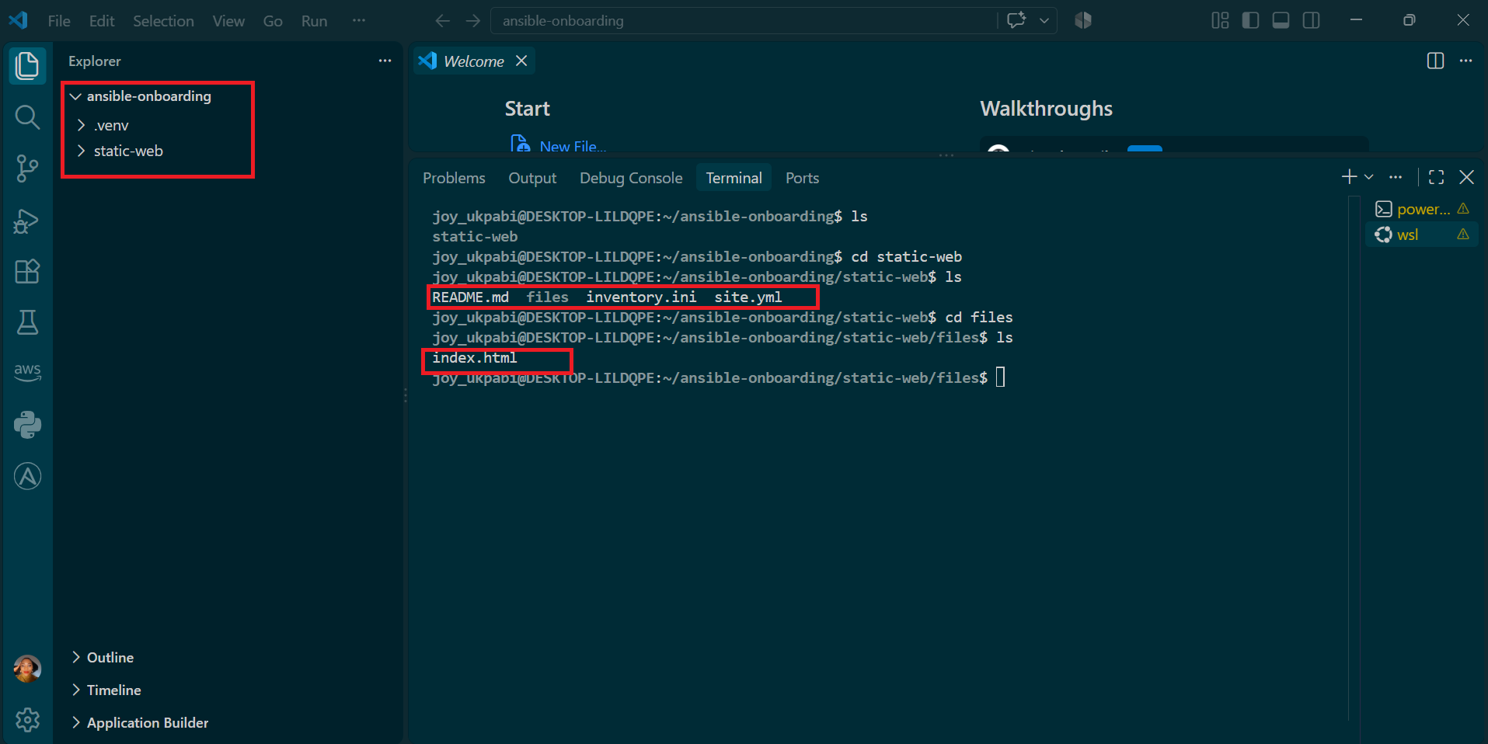

Explanation
The ansible-onboarding folder is reused because it is the shared Ansible controller workspace created in Assignment 1. It already contains the virtual environment and configuration used by later projects.
The static-web folder is created as a sibling project within this workspace. It contains the playbook, inventory, README, and files/ folder. The index.html file is kept inside files/ as the web content that the playbook will deploy to the managed servers.

Task 2 — Configure the Ansible Inventory
Goal
Add both existing web servers (web1, web2) to a new inventory file specific to this project, using the ansible_host alias syntax, so Ansible knows which two machines to target for the upcoming playbook.
Commands
cd ~/ansible-onboarding/static-web
nano inventory.ini
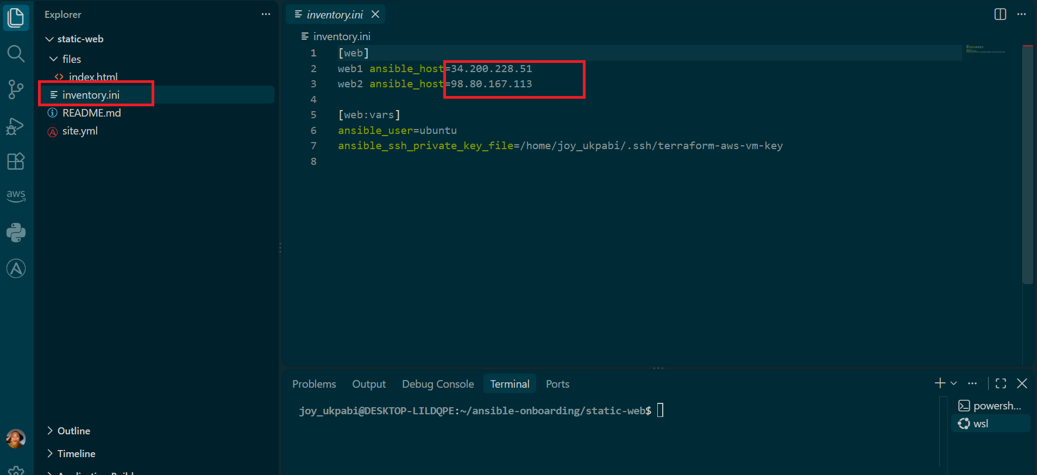
Verification
ansible-inventory -i inventory.ini --graph
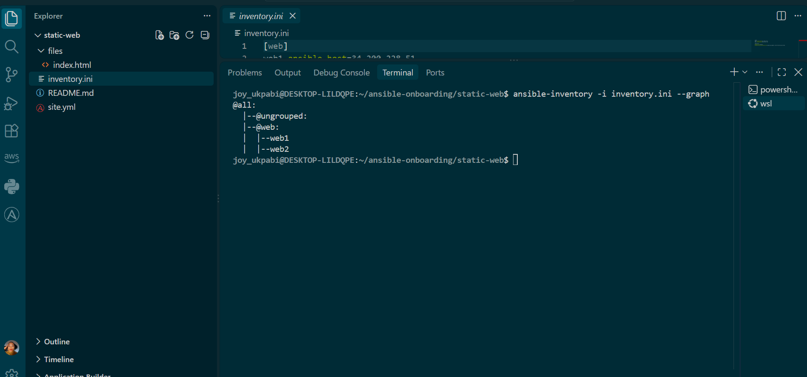

Explanation
The inventory file tells Ansible which servers it will manage and how to connect to them.
web1 and web2 are the names Ansible uses for the servers, while ansible_host specifies their actual IP addresses. The [web:vars] section defines the SSH user and private key used to connect to both servers.
To verify that Ansible can read the inventory correctly, run:
ansible-inventory -i inventory.ini --graph
The output confirms that both web1 and web2 are correctly placed under the web group. The inventory is therefore structured correctly and ready for Ansible to connect to the servers.

Task 3 — Verify Ansible Connectivity

Goal
Confirm that the Ansible controller can connect to both servers.

Command
ansible web -i inventory.ini -m ping
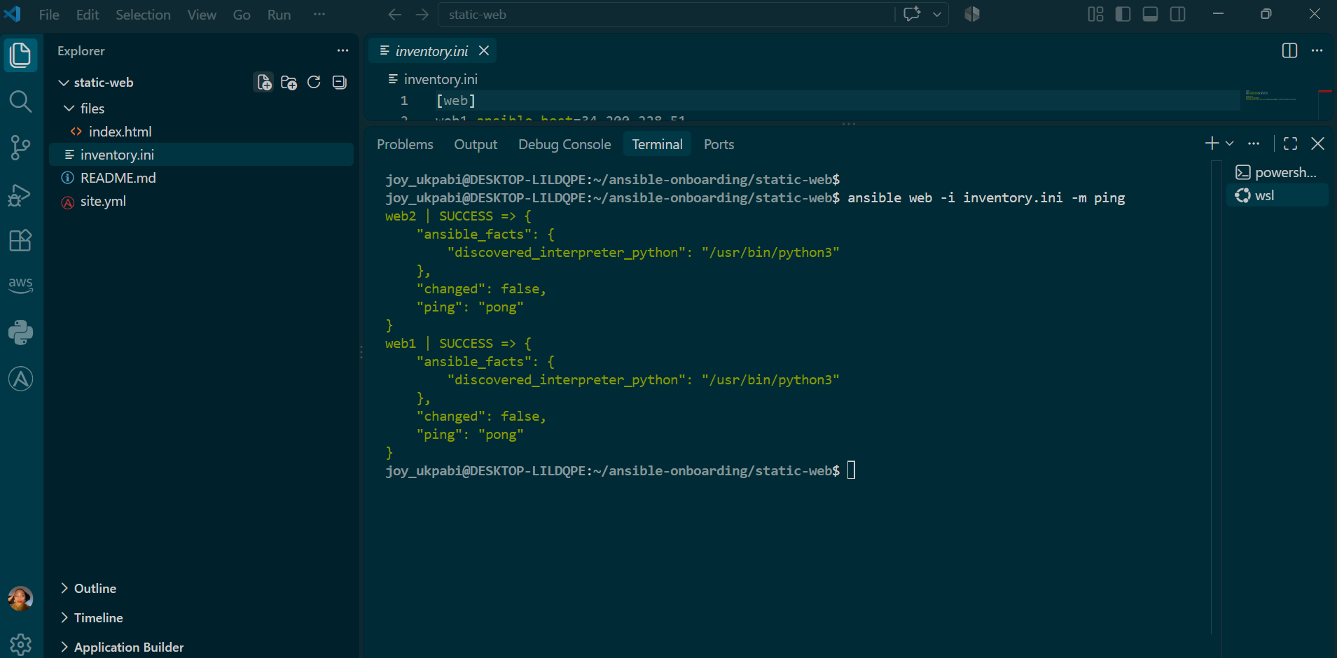

Explanation
The command targets the web group in inventory.ini, so it runs against both web1 and web2. The -i inventory.ini specifies the inventory file to use, while -m ping runs Ansible's built-in connectivity test.
Unlike a regular network ping, the Ansible ping module checks that Ansible can connect to the servers through SSH and successfully run its module. A pong response with SUCCESS confirms that both servers are reachable and ready for Ansible tasks.

Task 4 — Download and Personalize the Static Website

Goal
Download a real HTML file into the local files/ folder and personalize it with your name, so there's actual content for the upcoming playbook to deploy to both servers.

Commands
Step 1 : Confirm that you are inside the static-web directory.
bash
cd ~/ansible-onboarding/static-web
pwd

Step 2 : Download index.html into the local files directory.
Step 3: Confirm that the file was downloaded successfully.
bash
curl -L https://raw.githubusercontent.com/pravinmishraaws/Azure-Static-Website/main/index.html -o files/index.html
ls -l files/index.html

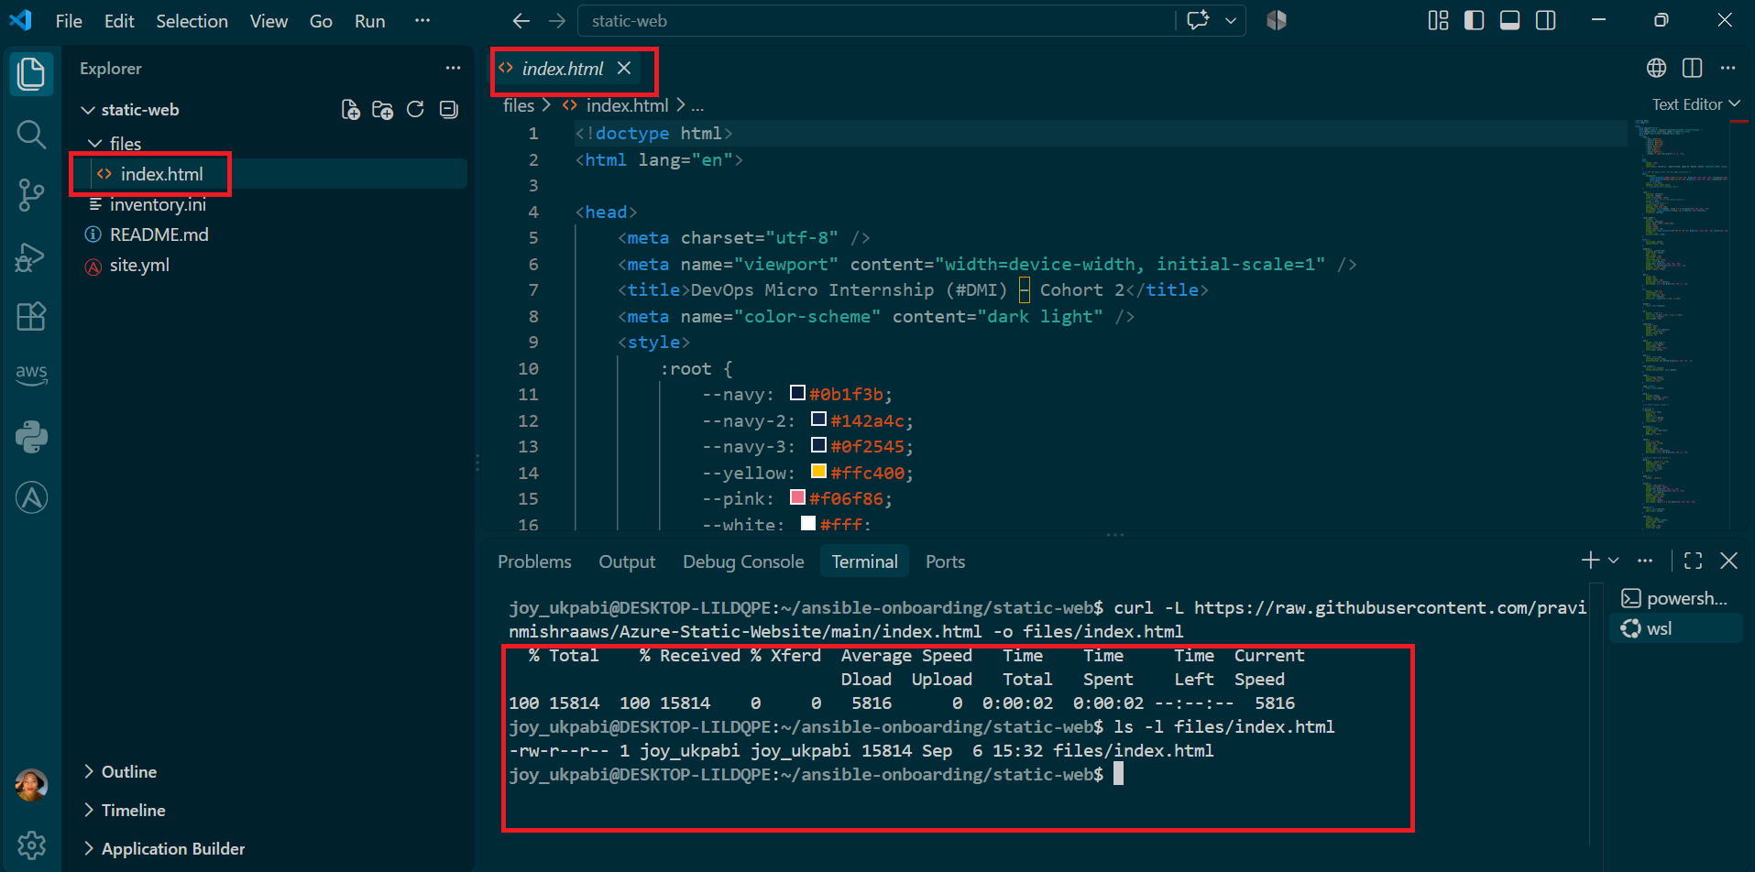

Step 4 : Add your name to index.html
- nano files/index.html.
- Press Ctrl+W, if in viscode; press Ctrl+F
- Type: Your Full Name
- Press Enter
This jumps the cursor to the line:
html
Hosted By <span id="yr"></span> Your Full Name •
5. Replace only “Your Full Name” with your actual name
Do not remove or modify the following element:
- <span id="yr"></span>
This element automatically displays the current year on the website.
6. Save and exit (Ctrl+O, Enter, Ctrl+X).

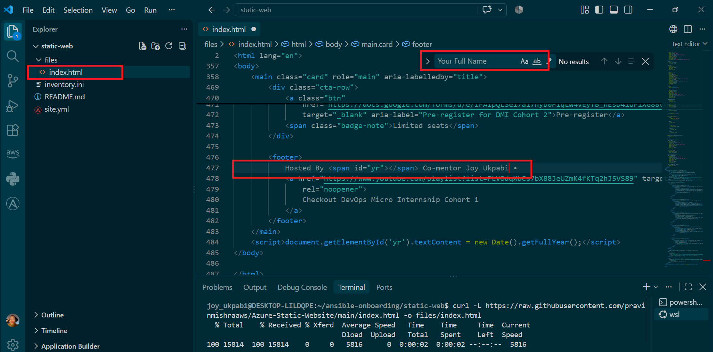
Verify the change:
bash
grep -n "Hosted By" files/index.htm
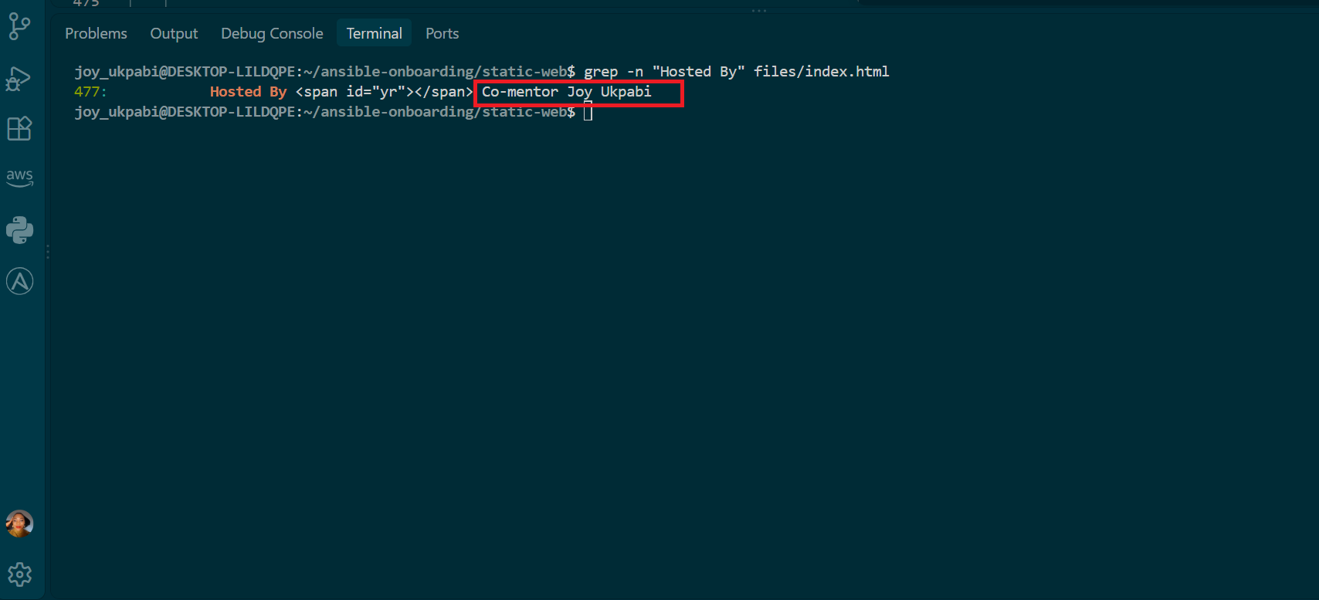
Explanation
The curl -L ... -o files/index.html command downloads the HTML file from GitHub and saves it as files/index.html, replacing the empty placeholder created earlier. The -L option allows curl to follow any redirects.
ls -l files/index.html confirms that the file was downloaded successfully by checking that it now has a file size greater than 0.
The name replacement is important because this index.html file is the exact content Ansible will copy from the controller to both web servers in the next task.
Finally, grep -n "Hosted By" files/index.html searches for the updated text and displays its line number, providing a quick confirmation that the change was made successfully.

Task 5 — Create the Multi-Play Ansible Playbook

Goal
Write site.yml, a single playbook containing three separate plays — install Nginx, deploy the website, and verify both servers respond — each with a distinct responsibility
Command
bash
cd ~/ansible-onboarding/static-web
nano site.yml
Content to add:
yaml
---
- name: Install and configure Nginx
hosts: web
become: true
tasks:
- name: Update the APT package cache
ansible.builtin.apt:
update_cache: true

- name: Install Nginx
ansible.builtin.apt:
name: nginx
state: present

- name: Start and enable Nginx
ansible.builtin.service:
name: nginx
state: started
enabled: true

- name: Deploy the static website
hosts: web
become: true
tasks:
- name: Copy index.html to the web root
ansible.builtin.copy:
src: files/index.html
dest: /var/www/html/index.html
owner: www-data
group: www-data
mode: "0644"
notify: Reload nginx

handlers:
- name: Reload nginx
ansible.builtin.service:
name: nginx
state: reloaded

- name: Verify both websites from the controller
hosts: localhost
connection: local
gather_facts: false
become: false
tasks:
- name: Send an HTTP GET request to each web server
ansible.builtin.uri:
url: "http://{{ hostvars[item].ansible_host }}"
status_code: 200
loop: "{{ groups['web'] }}"
register: website_checks

- name: Confirm each server returned HTTP 200
ansible.builtin.assert:
that:
- item.status == 200
success_msg: "{{ item.item }} returned HTTP {{ item.status }}"
loop: "{{ website_checks.results }}"

Save and exit (Ctrl+O, Enter, Ctrl+X).
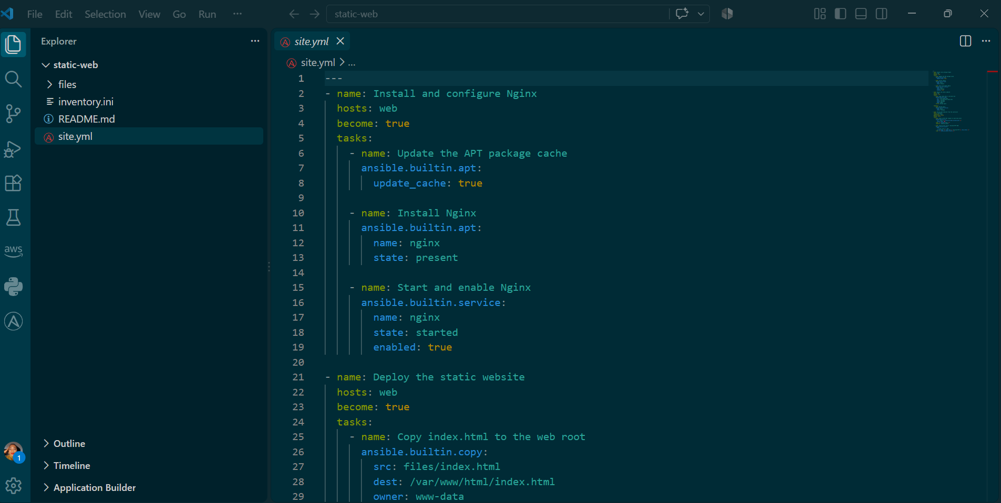
Before running the real playbook, check its syntax is valid:
bash
ansible-playbook -i inventory.ini site.yml --syntax-check

Explanation of playbook

What Is an Ansible Playbook?
An Ansible playbook is a YAML file that contains instructions for configuring and managing servers. Instead of manually logging into each server and running commands, the playbook describes what should be done, and Ansible carries out those tasks automatically.
A playbook can install software, create files, configure services, deploy applications, change permissions, and verify that everything is working correctly.

What Is a Play?
A play is a section inside an Ansible playbook that defines which servers should be managed and what should be done on those servers.
A single playbook can contain multiple plays, with each play performing a different part of the setup.
For example:
Playbook
→ Play 1: Install Nginx
→ Play 2: Deploy the website
→ Play 3: Verify the website
This makes the playbook easier to organize because each play has a specific purpose.

Play 1 — Install and Configure Nginx
This play targets the servers in the web group, so both web servers are configured. become: true gives Ansible administrator privileges because installing software and managing services require root access.
The tasks run in order. First, Ansible updates the package list, then installs Nginx, and finally starts Nginx and enables it to start automatically after a server reboot. ansible.builtin.apt manages the package, while ansible.builtin.service manages the Nginx service.

Play 2 — Deploy the Static Website
This play copies the files/index.html file from the Ansible controller to each web server. Ansible sends the file directly to /var/www/html/index.html, where Nginx can serve it.
The owner, group, and mode settings control the file's ownership and permissions. www-data is the user commonly used by Nginx on Ubuntu, while 0644 allows the owner to read and write the file and others to read it.
The notify: Reload nginx setting uses an Ansible handler. A handler is a task that runs only when another task reports a change. Therefore, Nginx is reloaded only when the website file has actually changed. If the file is already correct, Nginx is not unnecessarily reloaded.
The handlers section defines what the Reload nginx handler does. The name in notify must match the handler name exactly.

Play 3 — Verify Both Websites
This play runs on localhost, meaning the checks are performed from the Ansible controller rather than the web servers. The purpose is to confirm that the websites can actually be reached over HTTP.
gather_facts: false is used because system information is not needed for a simple website check. become: false is also used because administrator privileges are not required.
The loop goes through every server in the web group. For each server, Ansible gets its IP address from the inventory and builds the URL to check.
The uri module sends an HTTP request to each website, and register: website_checks saves the results. The final task checks those results and confirms that each website returned HTTP status 200.
A 200 status means the server successfully responded to the request, providing confirmation that both websites are reachable and working.

Task 6 — Validate the Playbook Syntax

Goal
Check site.yml for YAML or Ansible syntax errors before running it against real infrastructure — catching a typo or indentation mistake here is free; catching the same mistake mid-deployment against live servers is not.
Steps
- Confirm that you are inside the static-web directory.
- Run the Ansible syntax check.
Command
bash
cd ~/ansible-onboarding/static-web
ansible-playbook -i inventory.ini site.yml --syntax-check
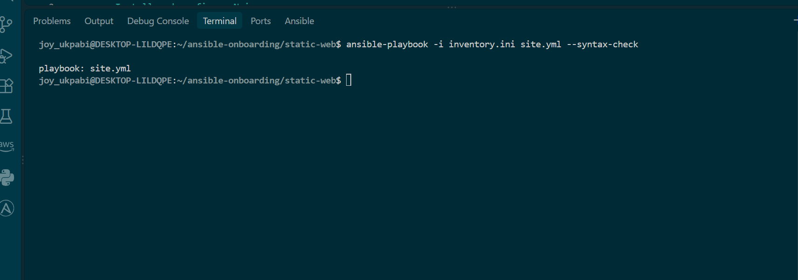

Explanation
- --syntax-check reads the entire playbook — all three plays, every task, and the handler — and checks that the YAML structure and Ansible playbook syntax are valid.
- It does not connect to any managed server or make any changes. This makes it a safe local check before running the playbook for real.
- Running the syntax check first helps catch problems such as incorrect indentation, missing YAML structure, or other syntax errors before Ansible attempts to configure real servers.

Actual Output
playbook: site.yml
This is the expected output when the syntax check succeeds. Ansible displays the playbook filename and does not report any syntax errors.
The result confirms that Ansible can successfully parse the playbook structure and is ready to move on to the actual execution with:
ansible-playbook site.yml

Expected Output
- playbook: site.yml

Task 7 — Run the Multi-Play Playbook
Goal
Execute all three plays for real — install Nginx, deploy the website, and verify both servers respond with HTTP 200 — in a single playbook run.
Command
bash
ansible-playbook -i inventory.ini site.yml
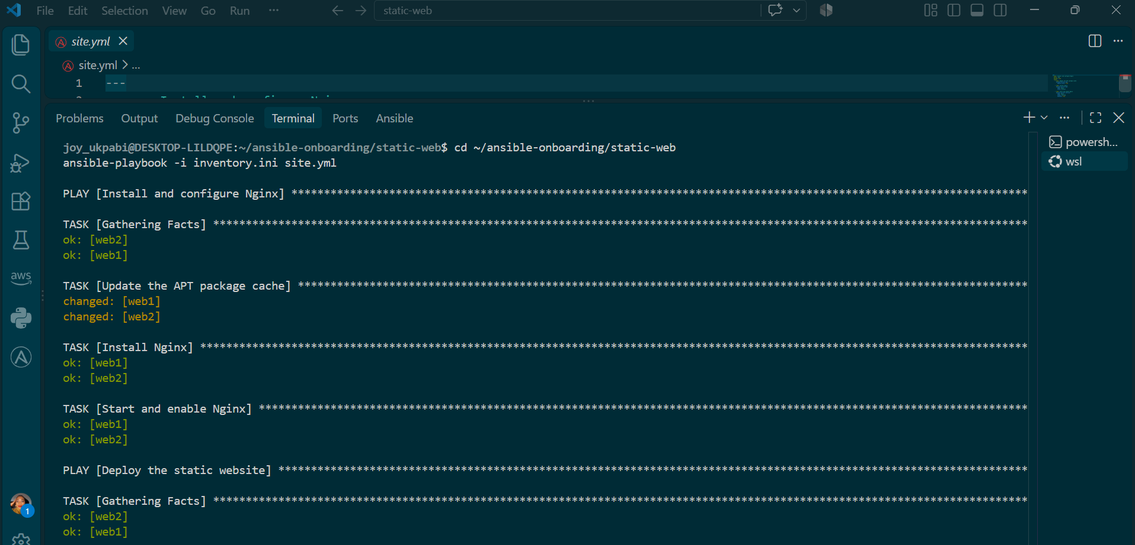
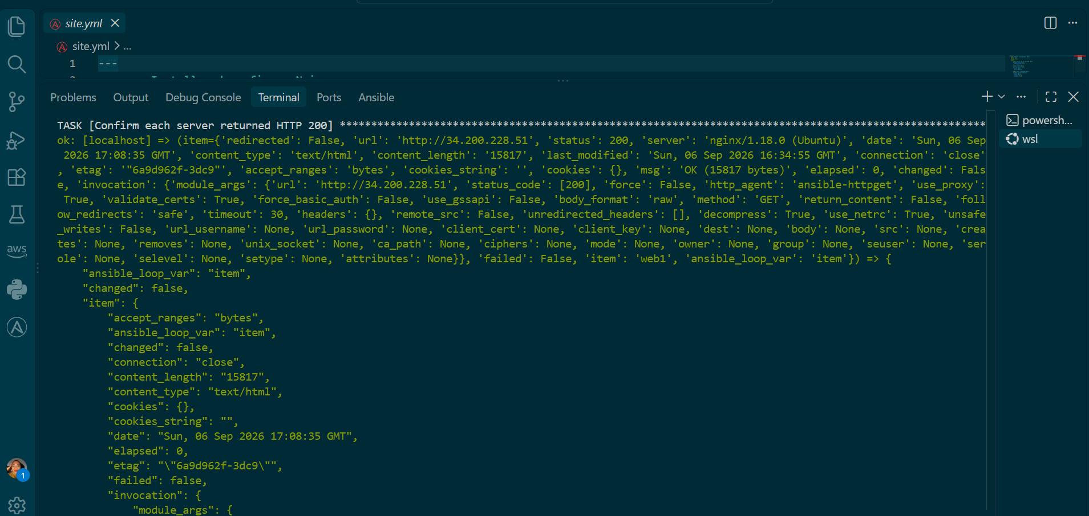
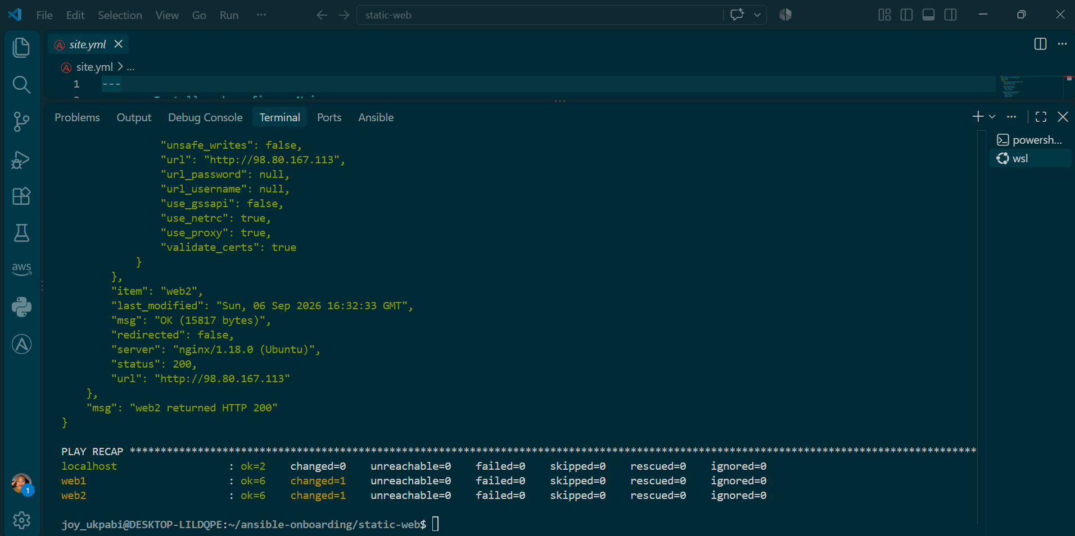

Explanation — What Happened During This Playbook Run

Overall Structure: Three Plays, Three Different Purposes
This playbook run executed three separate plays in sequence, each targeting a different set of hosts and each with a distinct responsibility: install software, deploy content, and verify the result. A play in Ansible is a self-contained unit that says "on these hosts, do these tasks" — and a single playbook file can chain several of them together, which is exactly what site.yml does here. Ansible always runs plays in the order they're written, top to bottom, and by default won't move on to the next play until the current one finishes across all its target hosts.

Play 1 — Install and Configure Nginx
TASK [Gathering Facts] ran first, automatically, before any of the play's actual tasks. This is Ansible's default behavior for any play that doesn't explicitly disable it (notice Play 3 later does disable it, for reasons covered below). Gathering facts means Ansible connects to each target host and collects a wide range of information about it — operating system, architecture, available memory, network interfaces, and more — and makes that information available as variables for the rest of the play to use if needed. Both web1 and web2 reported ok, meaning the connection succeeded and the facts were collected cleanly.
TASK [Update the APT package cache] reported changed on both hosts. This is expected behavior every time this task runs, not a one-off event — refreshing the package index (the equivalent of running apt update) pulls in the current state of Ubuntu's package repositories, which is data that changes over time, so Ansible correctly reports this as a change on essentially every execution.
TASK [Install Nginx] and TASK [Start and enable Nginx] both reported ok on both hosts. This is the idempotency principle in action: Nginx was already installed, already running, and already enabled from earlier work in this same session, so Ansible checked the current state, found it already matched what was requested, and made no changes at all. This is precisely the behavior that makes it safe to run a playbook repeatedly — tasks only act when there's actually something to do.

Play 2 — Deploy the Static Website
TASK [Gathering Facts] ran again here, since this is a separate play with its own hosts: declaration — Ansible treats fact-gathering per play, not once for the whole playbook run, so it repeats this step at the start of each play that requires it.
TASK [Copy index.html to the web root] reported ok on both hosts. Reading this carefully: ok here means Ansible compared the local files/index.html against what already exists at /var/www/html/index.html on each server, found them identical, and made no changes. This matters for what happens next — because the copy task reported no change, the handler that reloads Nginx was never triggered at all, and correctly doesn't appear anywhere in this run's output. Handlers in Ansible only fire in response to a task that reports changed; a task reporting ok is a clear, deliberate signal that nothing downstream needs to react to it. This is the practical value of the notify/handler pattern — it avoids reloading a live service unnecessarily on every single playbook run, only doing so on the specific runs where the underlying file actually changed.

Play 3 — Verify Both Websites From the Controller
This play behaves differently from the first two in several ways, each deliberate.
No fact-gathering task appears here at all, because this play explicitly sets gather_facts: false. The reasoning is that this play runs against localhost — your own controller machine — purely to send outbound HTTP requests to the two servers. Collecting detailed system facts about your own controller has no bearing on that task, so skipping it avoids unnecessary work.
TASK [Send an HTTP GET request to each web server] shows two separate ok results — one for item=web1, one for item=web2. This is a loop in action: rather than writing the same task twice with two different URLs hardcoded in, the task is written once and Ansible runs it once per item in a list (here, the two hosts in the web group), substituting in each host's actual address in turn. Both requests succeeded, meaning your controller received a real HTTP response from both public IP addresses.
TASK [Confirm each server returned HTTP 200] is where the actual verification logic lives, and the registered results reveal a lot of detail about what each server returned:
- web1 responded with "status": 200, identified itself as "server": "nginx/1.18.0 (Ubuntu)", and returned a body of "content_length": "15817" bytes.
- web2 responded with the identical status, the identical Nginx version string, and — notably — the exact same 15817-byte content length.
That matching byte count across two independently provisioned servers is a meaningful confirmation in itself: it shows both machines are serving byte-for-byte the same file, which is exactly the outcome a "deploy the same website to two servers" task is meant to prove. Each result also carries a "msg" field — "web1 returned HTTP 200" and "web2 returned HTTP 200" — which is the custom success message defined in the playbook's assert task, confirming the assertion (item.status == 200) evaluated true for both.
Both results also show "changed": false, which makes sense given what this play is actually doing — checking a website's response doesn't alter anything on the server or the controller, so false is the correct and expected value here, distinct from the earlier plays where changed meaningfully varied task to task.

Reading the Final Play Recap
localhost : ok=2 changed=0 unreachable=0 failed=0
web1 : ok=6 changed=1 unreachable=0 failed=0
web2 : ok=6 changed=1 unreachable=0 failed=0

The recap tallies every task's outcome per host across the entire run, and it tells a coherent story when read alongside the play-by-play detail above: localhost shows exactly two ok results and zero changes, matching Play 3's two purely read-only verification tasks. web1 and web2 each show one changed task — the APT cache refresh — with everything else settling into ok, meaning both servers had already reached, and remained in, the desired state. failed=0 and unreachable=0 across every host confirms nothing errored and every host stayed reachable for the duration of the run, which is the headline result the assignment is asking for.

Task 8 — Verify Idempotency
Goal
Run the exact same playbook a second time, with no changes to site.yml or files/index.html, and confirm nothing unnecessary happens — proving the playbook is genuinely idempotent, not just "safe to run once."
Command
ansible-playbook -i inventory.ini site.yml
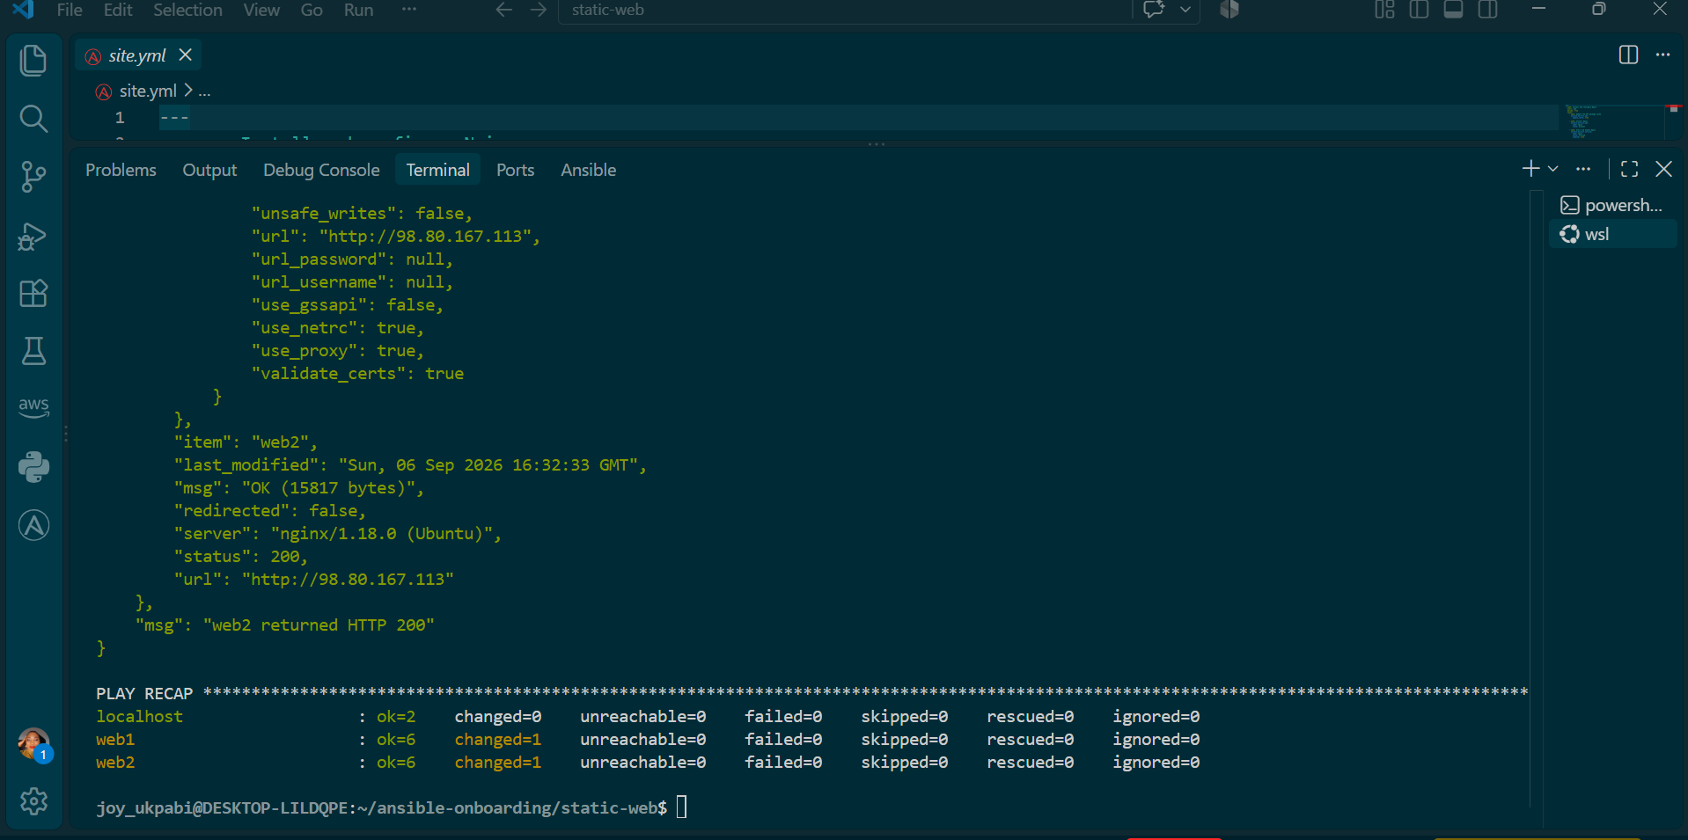

Explanation
This is the same playbook, run against the same two servers, with absolutely nothing changed on the controller side since the previous successful run. The purpose of running it again is to confirm a specific property of well-written Ansible automation: re-running it should be safe and should only report changed where something has genuinely changed since the last run — never simply because the playbook executed again.
What the results show:
- Install Nginx and Start and enable Nginx both reported ok on both hosts, exactly as in the prior run — nginx was already installed, running, and enabled, so nothing needed to change.
- Copy index.html to the web root reported ok on both hosts, not changed. This is the specific result that proves idempotency for the website deployment itself: Ansible compared the local files/index.html against what's already sitting at /var/www/html/index.html on each server, found them identical, and correctly made no changes.
- The Reload nginx handler did not run. This follows directly from the copy task reporting ok — handlers only fire when notified by a task that reports changed, and since nothing changed, the handler was correctly never triggered. This confirms the notify/handler relationship is working exactly as intended: Nginx is not being needlessly reloaded on a run where its configuration hasn't actually changed.
- Play 3's verification succeeded again, independently confirming both web1 and web2 still return HTTP 200, with web2's registered result showing "status": 200", "msg": "web2 returned HTTP 200", and a content_length of 15817 bytes — identical to the previous run, confirming the deployed content hasn't drifted between runs.
Final PLAY RECAP
localhost : ok=2 changed=0 unreachable=0 failed=0
web1 : ok=6 changed=1 unreachable=0 failed=0
web2 : ok=6 changed=1 unreachable=0 failed=0
failed=0 and unreachable=0 across every host confirms a clean run. The one changed=1 on each of web1 and web2 corresponds to the Update the APT package cache task — this task refreshes external repository index data and is expected to report a change on essentially every execution, since the underlying package metadata it's checking against changes over time on Ubuntu's servers, independent of anything in this playbook. This is a well-understood, harmless exception rather than a sign of non-idempotent behavior — every task actually responsible for this project's configuration (installing, starting, copying, reloading) correctly reported no unnecessary change on this second run.
What this demonstrates
Running the same playbook twice produced the same end state both times, with the second run doing meaningfully less work than the first — exactly the behavior idempotency is meant to guarantee. This is what makes Ansible playbooks safe to re-run as a matter of routine (for example, as a scheduled check, or after any manual troubleshooting on a server) without fear of duplicating installs, unnecessarily restarting services, or re-copying files that haven't changed.

Task 9 — Test Both Websites Manually
Goal
Independently confirm, outside of Ansible entirely, that both deployed websites are reachable and correctly serving your personalized content — via curl and a real browser.
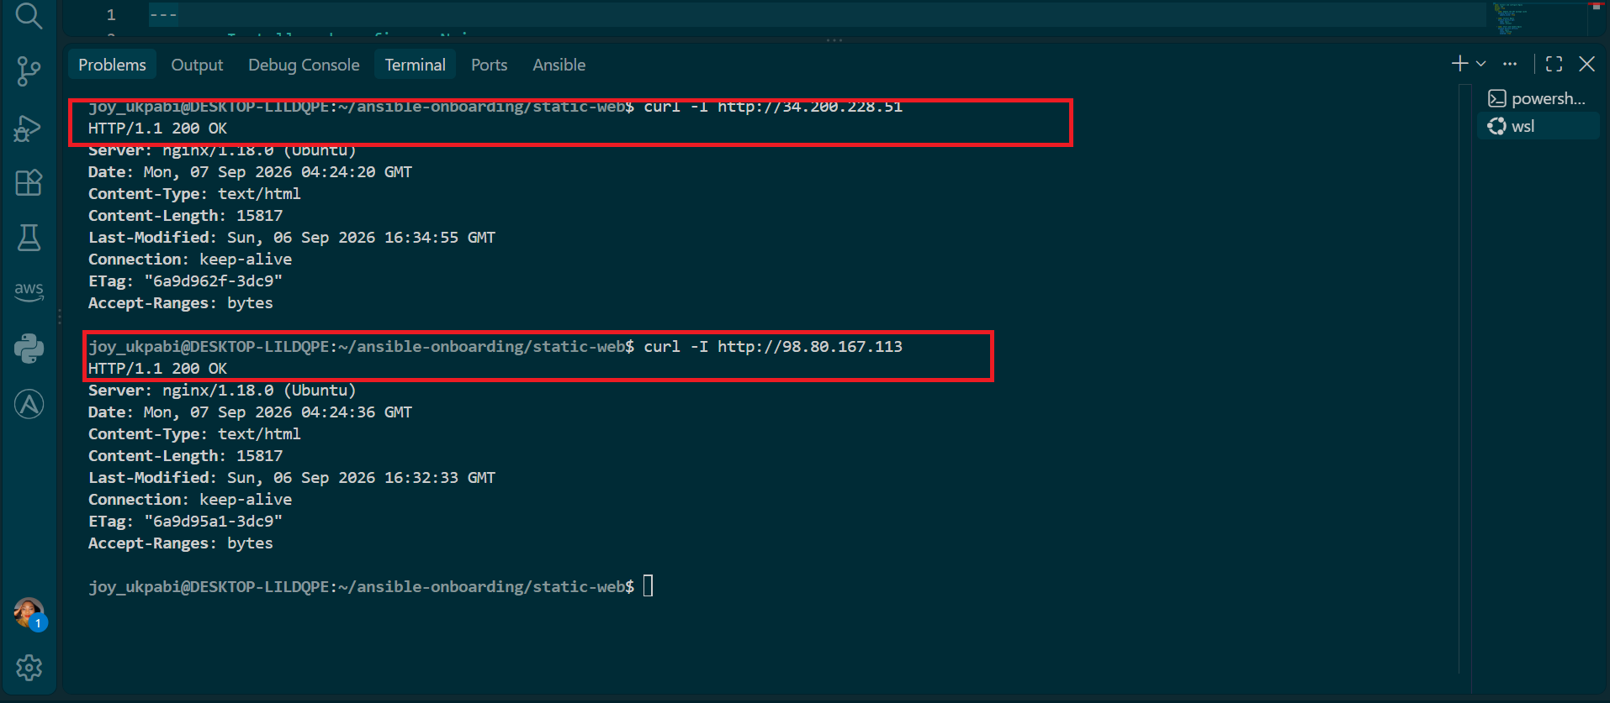

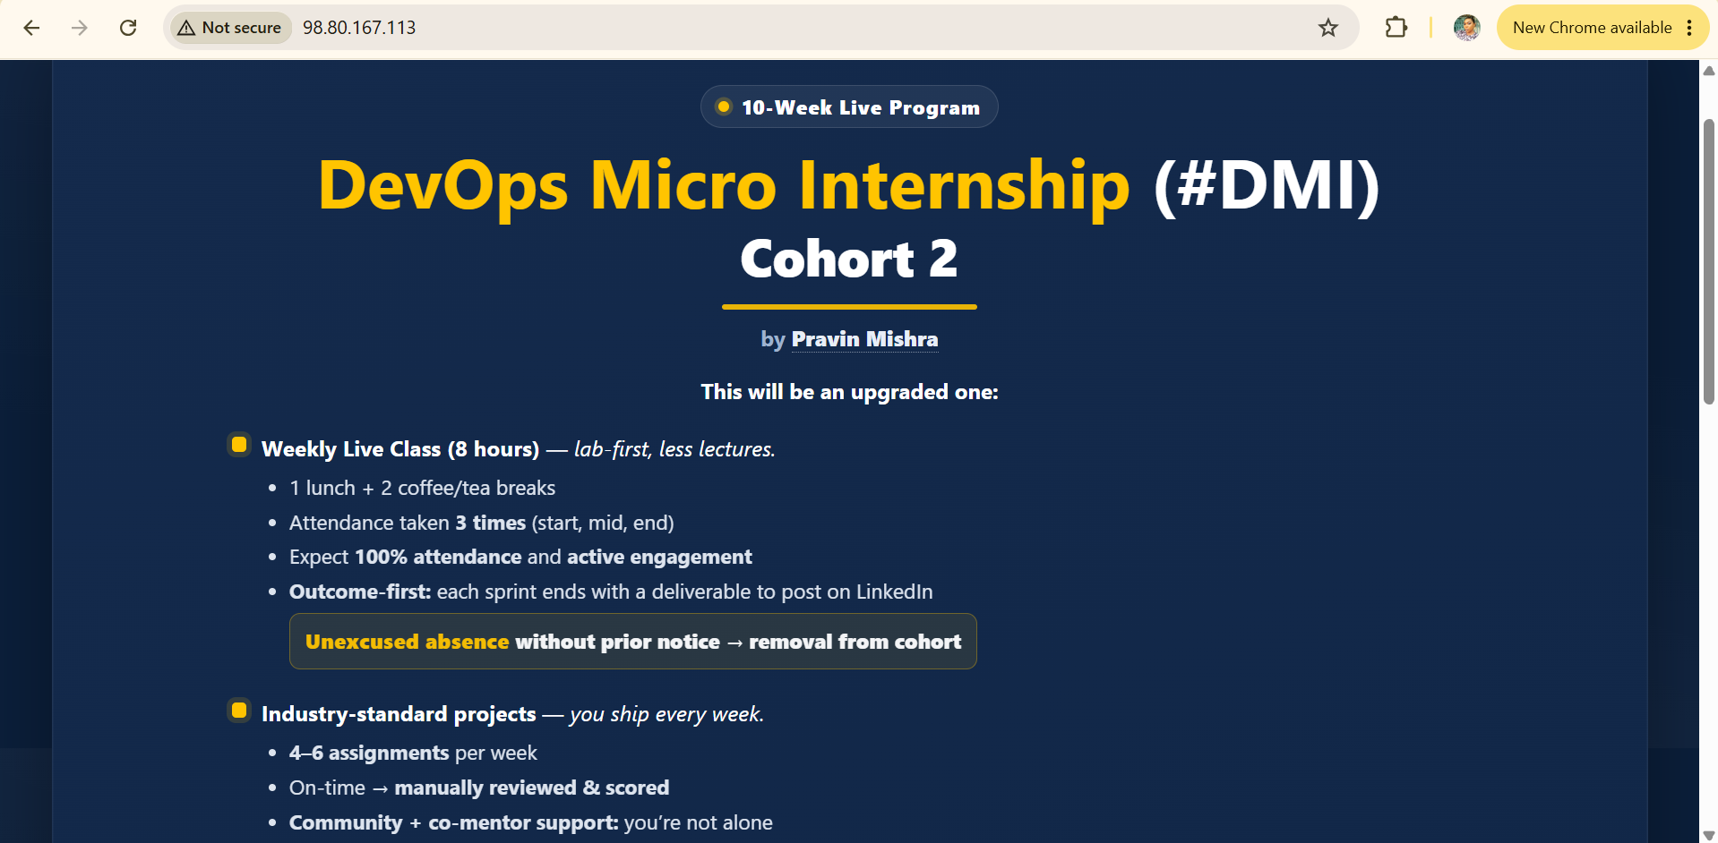

Explanation
- curl -I sends a request but only fetches the headers of the response, not the full page body — this is a quick way to confirm the server is up and responding correctly without needing to print the entire HTML to your terminal. The -I flag specifically requests a HEAD request rather than a full GET.
- Running this against both IPs separately confirms each server independently — this matters because Ansible's Play 3 already checked this same thing programmatically, but this step proves it manually, from a completely different tool and connection path, closing any doubt that Ansible's uri module result could have been misleading.
- Opening both addresses in an actual browser is the final, most literal proof: it shows the site rendering exactly as a real visitor would see it, with your name visible in the footer — something a raw HTTP status code alone doesn't demonstrate.
Expected output from curl -I:
HTTP/1.1 200 OK
Server: nginx/1.18.0 (Ubuntu)
...
Expected in the browser:
- The DevOps Micro Internship page renders correctly.
- The footer shows "Hosted By [current year] Co-mentor Joy Ukpabi" — confirming the personalization from Task 4 deployed correctly to both servers.
- Both public IPs load the identical page.

